Here are the procedures on how to fill-in online forms for DepEd Central, Regional and Dalaguete NHS offices:
1. Type dnhs6022.weebly.com in any web browser.
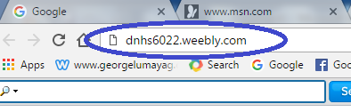
2. Press Enter key on the keyboard.
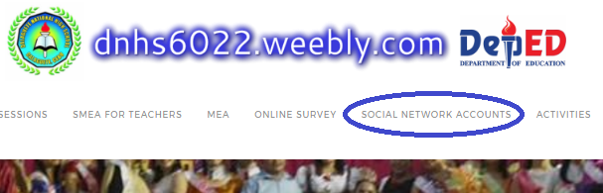
3. Click, hold and drag downward the horizontal bar.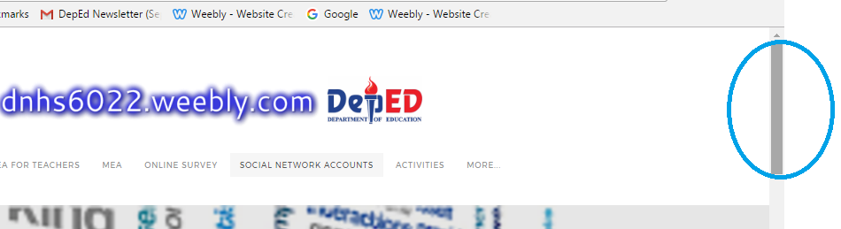
4. Part I. Click the Regional Office VII header.
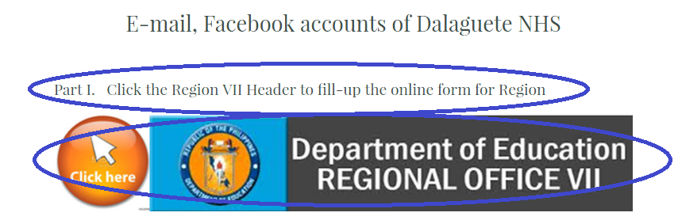

5. Fill-in data on the provided text boxes but please log-in first in your gmail account.
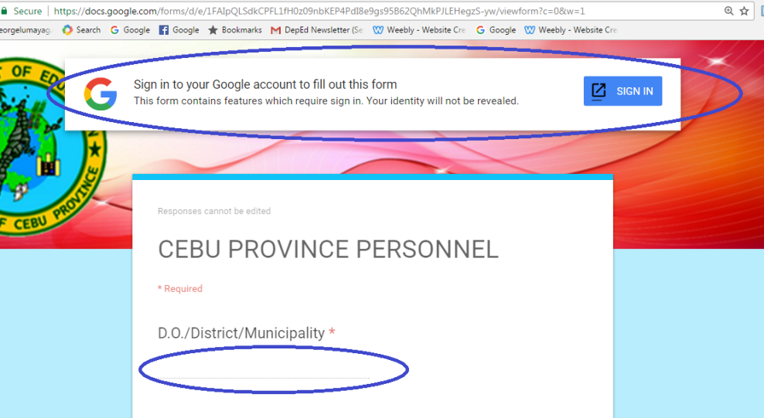
6. Click SUBMIT button to transmit data to Central and Regional offices.
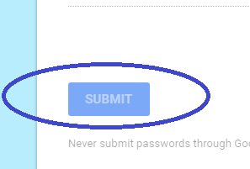
7. Click back the menu bar “Social Network Accounts” of the dnhs6022.weebly.com
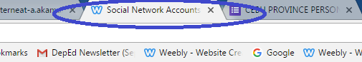
8. Part II. Fill-in the required information in the text boxes…
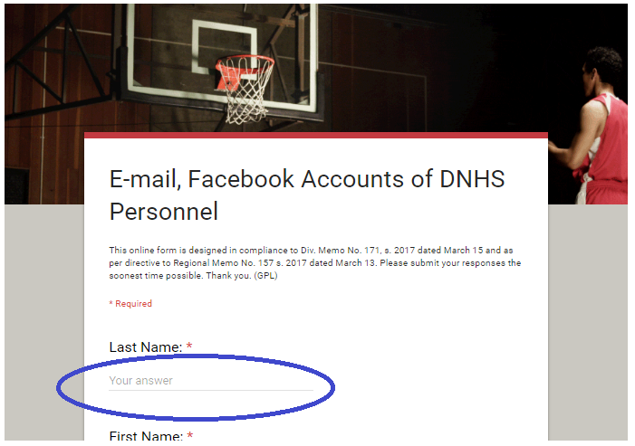

9. And finally, you click SUBMIT button for monitoring and consolidation of submitted responses as per directive of the Division Memo No. 171, s. 2017. The deadline is March 24, 2017. Failure to do so, the list of names and the total number of personnel who did not comply will be reported to DepEd Cebu Province Division. Please try to fill-in the online forms.

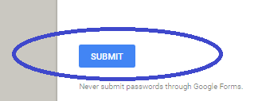
10. If you have viewed this image, your response has been recorded. Thanks.
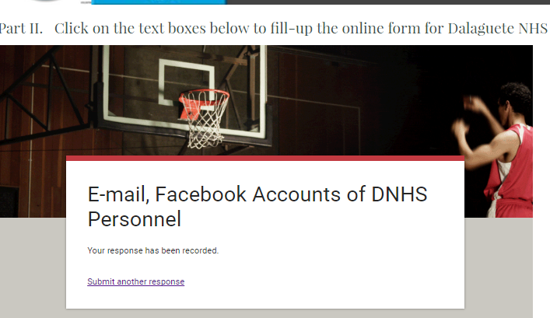

Prepared by:

GEORGE P. LUMAYAG ROGER D. BANOGBANOG
ICT Coordinator Principal IV
www.georgelumayag.com www.dnhs6022.weebly.com

